**SOIL 5813**

**Department of Plant and Soil Sciences Name: ____________________**

**Final Exam, Friday May 2, 2014**

**ARGENTINA LECTURE**

1. Provide a plausible explanation as to why no-tillage in the USA has not kept pace with the 70% adoption

noted in Brazil and Argentina.

2. In 1996,what specific technology assisted both Brazil and Argentina to make major strides in the

adoption of no-till?

3. What term is used in South America to better describe “no-till” ?

**RADIOISOTOPES**

4. Isotopes are atoms of the same element that differ in _____. They have the same number of ________

and _________ but have a different mass which is due to the number of ________

5. 22688Ra --> ______Rn + 42He + energy

(balance transmutation above)

1. Half Life is the amount of __________ needed for the __________ to reach _______ the original amount.
2. There are four stable or heavy isotopes of potential interest to researchers in soil and plant studies
3. (18O, 2H, 13C and 15N)
4. (18O, 2H, 12C and 15N)
5. (17O, 2H, 13C and 15N)
6. 15N14N is naturally present in the atmosphere at approximately ______% while the remaining 14N14N is 99.634%
7. N2 has three different atomic masses. What are they?

**PHOSPHORUS**

1. Could ordinary super phosphate be used to raise the soil pH if lime was not available? explain
2. How would P use efficiency be computed using the “difference method”?
3. In Central America, on volcanic ash soils, to improve P availability, what product was used to supersaturate the band with respect to Ca?
4. Why was this necessary?(#12)

**NITROGEN THEORY / FACTS**

1. Provide a comprehensive diagram of the Nitrogen Cycle (Showing all the pools, sinks, and transformations of Nitrogen).
2. Hodgen et al. (2009) showed that the uptake pattern of depleted 15N indicated an individual maize plant acquires most of its in-season N from an area within a _____ radius.
3. 20 cm
4. 30 cm
5. 40 cm
6. What is meant by the “salt rate” when discussing fertilizers and their placement with the seed at planting?
7. The critical salt rate (point at which seed damage occurs and germination is altered) for fertilizer placed with the seed in corn is ________ lb / ac
8. Why is it important to know whether or not Yield Potential (YP0) and Response Index (RI) are related?
9. Describe in detail the OSU algorithm used to decipher fertilizer N rates using mid-season NDVI readings. What are the components and how are they used to back calculate an N rate?
10. What is the Nitrogen composition (% N) in the grain of the world’s three major grain crops?
11. Urea hydrolysis consumes ________ thus increasing _________
12. How is NUE estimated using the difference method?
13. What kind of agricultural (crop) production systems have higher NUE’s ? Why?

**ALGORITHM THEORY**

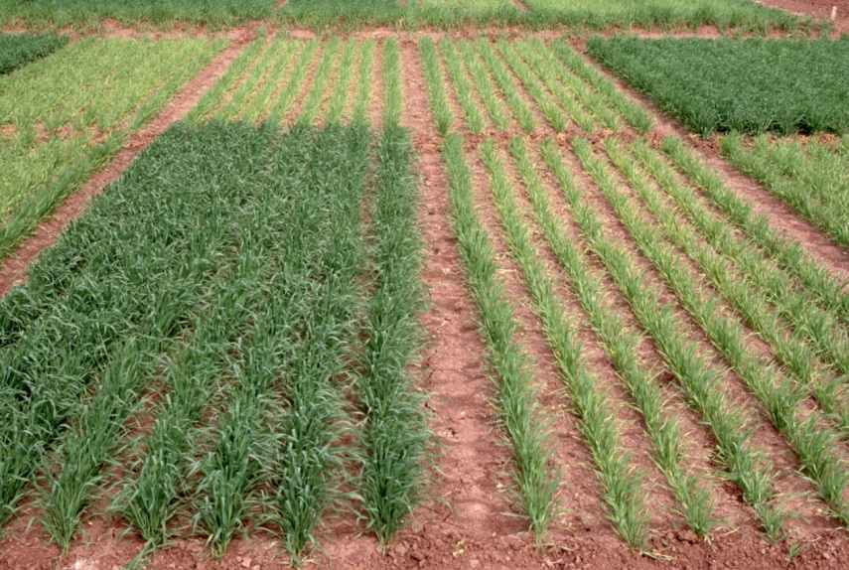

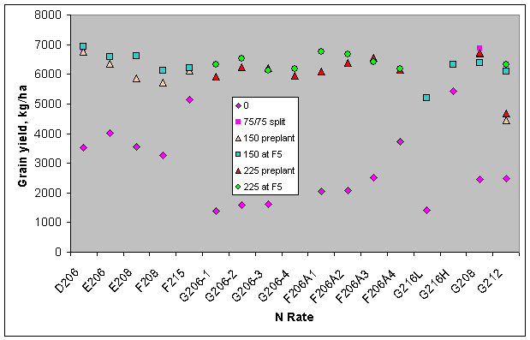

1. (using the graphs above) Work in NW Mexico showed that regardless of the level of mid-season N deficiency, they could apply N, mid-season and still achieve maxiumum grain yields. What fundamental requirement was necessary to do this?
2. When CV’s go up (measuring plant stand homogeneity) what does this do to fertilizer N rates?
3. The sufficiency approach uses one of the two components needed to derive accurate/reliable mid-season fertilizer N rates. What are the two components and how are they used (mathematically) to determine fertilizer N rates (OSU methodology).
4. Long term data from Experiment 502 (Lahoma) showed that
5. N response was independent of environment
6. N response was unrelated with yield potential
7. N response changed dramatically from one year to the next
8. Name 3 conditions/variables that could lead to heterogeneous plant stands in corn.
9. Professor R.A. Olson wrote the following paper we discussed in class (Economic and Agronomic Impacts of Varied Philosophies of Soil Testing Agron J. 74:492-499). What did hefind?
10. Sufficiency is known to be ______________ of the environment since increased root growth will expand into areas where contact exchange uptake is the same.
11. When the nutrient limitation is expressed as a percentage of the potential yield then the term _____________ may be applied.
12. It does not matter whether potential yield is 20 bu. or 30 bu., if the percent sufficiency is 80, then actual yield obtained (theoretically) will only be _____% of the potential yield.
13. Liebig’s law of the minimum could be interpreted as meaning that the crop used up all of the ________ nutrient in the soil, making the yield directly proportional to the amount of the ________ nutrient present and the crop content of the nutrient.
14. Draw the “root system sorption zone” and the “root surface sorption zone”. Which applies to mobile nutrients and which applies to immobile nutrients.
15. Does Bray’s mobility concept communicate something not published elsewhere? What would that be?
16. ____________ is a major amino acid formed in roots absorbing NH4
17. Unlike ammonium, ______ has to be transported to the leaves to be reduced and before being incorporated into an amino group
18. _________________ increased 35% when supplying 25% of the N as NH4 compared to all N as NO3 (Wang and Below, 1992).
19. _____________ were unable to absorb NO3, thus limiting yields otherwise increased by supplies of NH4 (Pan et al., 1984).
20. For the P solubility diagram below, what would be the final precipitate if DCPD were applied at a pH of

4.5

5.5

7.5

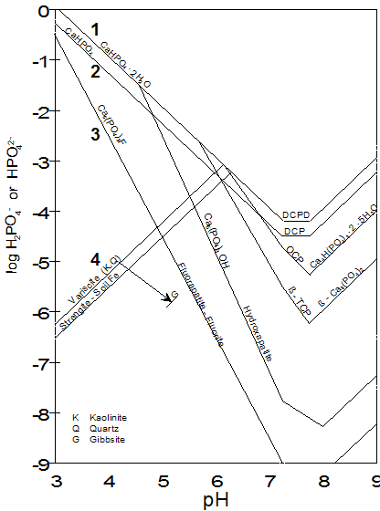

1. Web site discussed in class where world and by-country agricultural production data is located?
2. Grain N removal (yield * N concentration) in the world is the greatest for what crop? _____________ What two other crops follow? __________
3. World estimate of fertilizer nitrogen use efficiency for cereal crops is ________?
4. Developed nation cereal NUE is generally less than developing nation cereal NUE. Why?
5. What likely contributes to rapid urea hydrolysis and significant NH3 loss?
6. Sources for H+ supply include the following
7. Organic Matter
8. Hydrolysis of water
9. Al and Fe hydrous oxides
10. High sand content
11. “*When urea is applied to the soil surface, NH3 volatilization probably will not be economically serious unless the soil surface pH rises above 7.5” Who stated this and where did this work come from?*
12. Most important solid N fertilizer sold today
13. Likely the most efficient and economical source of fertilizer N sold today
14. In the early 1960’s __________________ was the primary solid N product in world trade
15. During hydrolysis, soil pH can increase to >________ because the reaction requires _________ from the soil system.
16. Westerman et al. (1993) showed that soil-profile-accumulation of NH4-N and NO3-N was unlikely to occur in long-term winter wheat experiments unless
17. N rates exceeded that required for maximum yields
18. N rates were less than that required for maximum yields
19. Total amounts of N were split applied
20. Which of the following were N buffering mechanisms delineated in class

1. Increased Applied N results in increased plant N loss (NH3)

2. Higher rates of applied N - increased volatilization losses

3. Higher rates of applied N - increased denitrification

4. Higher rates of applied N - increased organic C, - increased organic N

1. Fill in the two blanks



1. For the following what would be the norms for accepted yield goals

Pounds of N required per bushel of wheat ______________

Pounds of N required per bushel of corn _____________

1. Two major switches exist for the Nitrogen Cycle. What are they?
2. In order for ammonium and nitrate-N to make their way into an amino group, what intermediate, gaseous product is formed?
3. What are the four sinks for N loss delineated in the Nitrogen Cycle?
4. Teal et al. (2007) noted that normalized difference vegetative index (NDVI) readings in corn could be used to predict grain yield potential (V8 growth stage).

T or F

1. Work in Oklahoma showed that Soil organic C __________ when N was applied at rates in excess of that required for maximum yield.
2. ___________ = highest yield attained in the last 4-5 years + 30%
3. When Yield Goals are used it explicitly places the risk of predicting the environment (good or bad) on the _____________________
4. T, F, Nutrient removal can be reliably estimated for a given yield level in specific crops
5. In order to describe the variability encountered in field experiments, soil, plant and indirect measures should be made at the ______ resolution.
6. Vigil and Kissel (1991) included the _______________ to better predict potential N mineralization in soil.
7. Three largest sinks of carbon on earth are

______________ 38,000 GT

______________ 10,000 GT

______________ 1,500 GT

1. If a procedure for N analysis had a precision level of ± 0.03% what would this be in pounds/ac ?

(values you may need are listed below)

ppm = % * 10000

1.0% = 10,000 ppm

0.01% = 100 ppm

ppm* 2 = lb/ac

(0-6”, Pb*ppm*1.3597254) Pb=1.47

± 0.01% = ± 200 lb/ac

1. The percent increase in atmospheric CO2 due to a worldwide decrease of up to 3% soil organic matter (arable land) would have accounted for _______ to _______% of the 80 mg kg-1 (260 to 340) increase in atmospheric CO2 over the last 150 years (Mullen et al., 1999).
2. _______________ appears to be the only agricultural system that could realistically be implemented to reduce global CO2 levels with a calculated increase of 4:6*108ha (a 52–66% growth in worldwide area)
3. The Rationale in a good “abstract” should do what?
4. “*You have to look and be able to see things that other people looked at and didn't see before. How do you do that? There's two ways. Either you make a new instrument, and it gives you better eyes, like Galileo's telescope. And that's a great way to do it, make such a nice instrument that you don't have to be so smart, you just look and there it is. Or you try to internalize it in such a way that it really becomes intuitive.”*

*A.* Who stated this?

B. Give an example in your life where this concept could be applied?

**BONUS:**(5 points)

Outline the countries of Costa Rica, Uganda, Turkey, Somalia, and Libya

