Bill Raun, John B. Solie, Marvin L. Stone,
Gary E. Varvel, Matthew D. Ruark, Jeremiah Mullock, Bee Chim, and Brian Arnall.
bill.raun@okstate.edu
jsolie@okstate.edu
mstone@shieldedpair.net
gary.varvel@ars.usda.gov
mdruark@wisc.edu 158 Soil Science, Madison WI
jeremiah.mullock@okstate.edu

Relationship between yield potential and nitrogen responsiveness in long-term experiments

Are Yield Potential and Nitrogen Responsiveness Independent?

Abstract
Cereal grain fertilizer nitrogen (N) recommendations should conform to accepted theory. The objectives of this study were to evaluate the relationship between yield potential (yield level) and nitrogen (N) responsiveness in long-term winter wheat (Triticum aestivum L.) and maize (Zea mays L.) field experiments in Stillwater (58 years) Altus, OK (45 years), Arlington, WI (49 years), and Shelton, NE (13 years). Nitrogen responsiveness or the response index (RI) was determined by dividing the grain yield from high N rate plots by the yield from either the 0-N fertilizer check (RI 0-N) or medium N rate plots (RI mid-N). For the five long-term trials reported here, yield and N responsiveness were not related whether or not a medium N rate or the check plot (0-N) was used as the reference. Because both yield level and N responsiveness impact N demand, this requires that both be included in the formulation of N fertilizer recommendations. Knowledge that yield level and N responsiveness are independent requires that both be considered as separate variables in the formulation of N fertilizer recommendations.

Introduction
Liebig’s law of the minimum stated that the nutrient present in the least relative amount is the limiting nutrient (Bray, 1954). Bray (1954) further noted that Liebig’s law of the minimum could be interpreted to mean that the crop used up all the deficient nutrient in the soil, making yield directly proportional to the amount of deficient nutrient present and the crop content of that nutrient. Stanford (1973) reported that optimum use of N included the N requirement of the crop at an expected level of yield, the amount of N mineralized during the season, the amount of residual N present early in the season, and the expected efficiency of the N to be applied. Stanford (1973) concluded that the validity of N fertilizer predictions depend on realistic estimates of yield, efficiency, and residual mineral N supply. It could also be surmised that an estimate of the response index and expected yield potential would be the accompanying wording used today. What is clear in this discussion is that many authors have delineated the need for knowing what the N response would be and that this in turn needed to be tied to the expected or predicted yield potential.

Importance of Yield Potential (Yield Goal) for making N recommendations
Knowledge that crop N demand increases with increasing yield, is evidenced in numerous research articles that follow. Work by Spiertz and De Vos (1983) indicated that winter wheat N rate recommendations should be based on the amount of residual soil nitrogen and the crop requirement in a given environment, where both components were expected to vary considerably due to environmental constraints. They further reported that an accurate assessment of the potential yield level for different growing conditions would improve N fertilizer recommendations. Ying et al. (1998) showed that nitrogen requirements increased with increasing yield for high-yield rice (Oryza sativa L.) in tropical and sub tropical environments. Work by Fowler (2003) noted that N fertilization rates increased when grain protein concentration targets increased for high yield potential wheat varieties. Schepers et al. (1992) suggested that SPAD 502 chlorophyll meter readings may provide a better estimate of potential yield than leaf N concentration. Mullen et al. (2003) reported the importance of first recognizing yield potential. Ensuing fertilizer N rates would subsequently depend on the likelihood of obtaining a response. Lory and Scharf (2003) concluded that fertilizer recommendation systems that ignore yield entirely are likely limited to explaining less than 50% of the variation in the economic optimum N rate. Work by Raun et al. (2001) focused on predicting actual wheat grain yield using mid-season spectral measurements. They reported that the normalized difference vegetation index (NDVI) collected from winter wheat at the Feekes 5 growth stage (Large, 1954) divided by the cumulative growing degree days (GDD) could be used to predict final grain yield over various sites and years, where wheat had been planted and sensed at different times. Fox et al. (1994) noted that chlorophyll meter readings could not be used to accurately predict fertilizer N rates for economic optimum yield. Based on known amounts of N in the grain for the different crops (Tkachuk, R. 1969), predicted removal (yield goal * percent grain N) responsibly targets nutrient need by dividing this value by an expected efficiency. What is important to note in this discussion is that for the most part, fertilizer N rates have been based on a given level of yield, and that yield goals have been a starting point.

Importance of N Responsiveness for making N recommendations
Mullen et al. (2003) reported that the in-season response index (RI) based on NDVI sensor readings from a non-N limiting reference area (N Rich Strip) divided by NDVI readings from the farmer practice was a viable method for identifying environments where the potential to respond to N fertilizer exists. Similar work by Varvel et al. (1997) computed a sufficiency index (SI) using chlorophyll meter readings from the farmer practice divided by chlorophyll meter readings from a non-N limiting reference strip. For corn, SI’s lower than 95% indicated an N deficiency thus requiring additional N (Varvel et al., 1997). Research conducted over locations and years in Missouri noted that economically optimum fertilizer nitrogen rates vary widely from year to year, field to field and from place to place within a field (Peter Scharf, personal communication, February 2012). Similarly, Mamo et al. (2003) reported that temporal variations must be considered with site-specific N fertilizer management. Scharf et al. (2005) noted that economically optimal N fertilizer rates for corn were very different between fields and highly variable within fields. Related work by Bundy and Andraski (2004) with winter wheat noted that optimum N fertilizer rates over 21 site years varied significantly, ranging from 0 to 170 kg N ha⁻¹. This same work showed that yields at the economically optimum N rates ranged from 2.89 to 5.58 Mg ha⁻¹.

Nutrient Management Theory
Fundamental theory for making fertilizer N rate recommendations varies widely. Over the years recommendations have predominantly been based on a yield goal established prior to planting. Early work by Dahnke et al. (1988) indicated that the yield goal was the “yield per acre you hope to grow.” Rehm and Schmitt (1989) established that the use of soil moisture at planting could improve the accuracy for establishing at-planting-yield-goals. More recently, North Dakota, preplant N rates have been based on relative historic productivity, either low, medium or high, in one of 3 main regions within the state where different N rate responses are expected (http://www.soilsci.ndsu.nodak.edu/wheat/index.html). Other yield goals in the Mid West have been determined by averaging yields from the last 5 years, and adding 30% to that value. While problematic, the use of 2 lb N/bu wheat or 1.2 lb N/bu corn is an improvement over what farmers often do (same historical rate, year after year). With adequate soil moisture at planting, Rehm and Schmitt (1989) reported that it would be smart to target a 10 to 20% increase over the recent average when selecting a grain yield goal. They also suggested that if soil moisture is limiting, the use of past maximums, and an average may not be the best method for setting a grain yield goal for the ensuing crop. In addition, the use of farm or county averages was not recommended for progressive farmers concerned with high farm profitability (Rehm and Schmitt, 1989).
Other work in mid-Western states report N rate recommendations computed using the cropping system (corn following corn, and corn following soybean), selected regions, and price ratios (http://extension.agron.iastate.edu/soilfertility/nrate.aspx). At current day prices ($0.50/lb N, and $6.00 bu corn), the economic N rate recommendation for Iowa was between 185-210 lb N/ac, and generally lower for Minnesota, Michigan, and Ohio. This work further notes that the flat net return surrounding the N rate at MRTN (maximum return to N) reflects small changes near the optimum N rate, and indicate that choosing an exact N rate is not critical to maximize profit (Sawyer et al. 2006). They also noted that because of a poor relationship between yield and economic optimum N, their regional N rate guideline did not incorporate yield level. Work by Dinkins and Jones (2007) at Montana State University recommend subtracting soil NO₃-N (0-24 inches) from the amount of fertilizer N required to attain a specific yield potential. Similar work by Schmitt et al. (2008) recommended subtracting late fall or spring preplant soil NO3-N from the N fertilizer rate recommended that was derived from a realistic yield goal.
Recent work by Raun et al. (2011) showed that there was no relationship between N responsiveness and yield level in three long-term experiments in Nebraska and Oklahoma. Because yield and N responsiveness were consistently independent of one another, and because both affect the demand for fertilizer N, it was recommended that estimates of both be combined to calculate realistic in-season N fertilizer rates. The objective of this work was to acquire added data sets from long term maize and wheat trials and to determine if yield potential and N responsiveness were related.

Materials and Methods
Grain yield data from five long-term field experiments were evaluated from Oklahoma, Nebraska, and Wisconsin (Tables 1 and 2). All long term trials had plots where N was applied annually at different N rates and a zero-N check. Long term trials included in this analysis were the Magruder Plots (Girma et al., 2007), a long term maize study near Shelton, NE (Varvel et al., 2007), a long-term maize trial near Arlington, WI (Bundy et al., 2011), and two long-term winter wheat trials near Altus, OK (Raun et al., 1998). These 5 long-term trials were not included in the analysis reported by Raun et al. (2011) that addressed this same topic. Each long-term experiment, year initiated, actual years included in the analysis, and soil type are reported in Table 1. Fertilizer N rates, and sources used in each long-term experiment are included in Table 2. At Magruder, only years from 1958-present were included due to the noted differences in yield potential as a function of improved genetics. For the long term corn trial at Arlington, WI, years were divided into two groups, 1958-1983, and 1984-2007. These two groups coincided with noted differences in yields due to improved hybrids, higher planting populations (79,000 to 86,000 plants/ha) and an increase in the N rate applied. For both long-term winter wheat trials at Altus, all years (1966-2011) were included in this analysis. At each site, regression analysis with grain yield used the highest yield observed in any year, regardless of treatment. The highest yielding plots did not always come from the highest N rate in all experiments.
Linear regression of grain yield (highest observed treatment yield in any year) with RI, and year were evaluated at all sites. Noteworthy was that RI was computed using two different methods: grain yield from the high N rate plot divided by the check or 0-N plot (RI 0-N), and grain yield from the high N rate plot divided by the yield from the middle N rate (RI mid-N). The different methods of computing RI (RI 0-N and RI mid-N) were used to better reflect what N response as a function of the environment would be when simulating what the farmer would find (RI mid-N). The RI 0-N method would likely over estimate N demand and estimated responsiveness since soil N levels would be continually depleted (check plots receiving no N year after year). Using this added method of determining N responsiveness was considered important in terms of providing robust estimates of RI and that was not accomplished in the Raun et al. (2011) manuscript. No mid N rate was included in the non-replicated 6 treatments from the Magruder Plots that were started in 1892. However, for Experiement 406, Experiment 407, Arlington WI (1958-1983), Arlington WI (1984-2007), and Shelton, NE, the computation of RI mid-N (high N rate, kg ha⁻¹/mid-N rate, kg ha⁻¹ ) used 180/45, 89/45, 112 to 280/56 to 140, 140 to 168/252 to 280, and 200/100, respectively. For both time periods used for the Arlington WI site, the high N rate, or numerator, was always greater than the mid rate, or denominator for the computation of RI mid-N.

Results
Regression model results for the relationships between response index (RI mid-N and RI 0-N), grain yield, and year, for Magruder, Experiment 406, Experiment 407, Arlington WI (1958-1983 and 1984-2007), and Shelton, NE are reported in Table 3. Linear regression for these six data sets showed that no significant relationship existed between RI and grain yield whether or not RI was determined using the check plot or the mid-N rate. Coefficients of determination (r²) values were all less than 0.10. The linear relationship between grain yield and year did show that a significant positive slope existed in 2 of the 6 data sets (Table 3). Both of these incidences were recorded at Arlington WI (1958 to 1983 and 1984 – 2007) where 16 different improved maize hybrids have been planted since 1986. To a certain extent, this was expected since yield potentials have increased over time due to increased genetic potential (Hammer et al., 2009). Nonetheless, at the other four sites, there was no relationship between grain yield and year, demonstrating the unpredictability of grain yield over time (Table 3). With knowledge that improved winter wheat varieties with higher yield potentials were periodically introduced in Experiment 406, Experiment 407, and Magruder, a positive relationship between year and maximum grain yield could have been expected. Because this was not observed (Table 3), it further supports findings that reveal the difficulty in predicting or setting yield goals. It should also be noted that minimum, maximum, and average yields varied widely at all sites (Table 4) and that showed no identifiable trend with time.

Finally, whether or not RI was determined using the 0-N rate and the mid-N rate, no relationship was found with year at any location (Table 3). While there was a tendency for yields to increase with time at Arlington (both sets of years), and Experiment 407, this did not translate into a tendency for increased RI’s with time, even though the demand for N could have increased. Again, this reflects the unpredictability of both N responsiveness and grain yield over time in all long-term trials reported.
Discussion
Research by Raun et al. (2011) demonstrated that grain yield levels (yield potential) for maize and wheat were independent of N responsiveness or RI. This coming from analysis of two long-term winter wheat and one long-term maize experiment in Oklahoma and Nebraska respectively. They further reported that because yield potential and N responsiveness were not related, both should be used to generate mid-season fertilizer N rate recommendations since both will influence fertilizer N demand.
The biological reasons that would explain why yield potential and N responsiveness are independent of one another include knowing that there are wetter than normal years when yield levels are high, but where limited N response to fertilizer has been reported. Similarly, finding large increases in yield from applied N in mild/dry years is not unusual. The influence of environment on N demand is varied and equally unpredictable. A consequence of unpredictable weather effects on crop requirements has been to use reference plots (high N rates) and crop sensing prior to in-season N application (Tremblay and Belec, 2006). This is then bound to the understanding that weather is the primary driver of both plant growth and soil conditions, and that change dramatically year to year.

Algorithm
If both yield potential and N responsiveness are important as has been delineated by several authors, shouldn’t both be considered for making fertilizer N rate recommendations? Can either be used alone, or should they both be used as independent variables? The first question that needs to be answered is does yield potential influence the ultimate demand for fertilizer N. Clearly the answer is yes and that has been documented in numerous research articles in agriculture (Cassman et al., 2002; , ). The second question is whether or not weather influences the demand for fertilizer N from year to year, and/or whether or not optimum N rates change from year to year, but at the same yield level. Regardless of how this last question is posed, there are copious amounts of research showing that optimum N rates for cereal production do in deed change year to year, and by amounts that are highly significant (Scharf et al., 2005; Bundy and Andraski, 2004).
Understanding that both N responsiveness and yield potential influence the final demand for fertilizer N, and knowledge that they are independent of one another, illuminates the need to consider both, independently, if accurate mid-season fertilizer N rates are to be realized.

Independence of Yield Potential and RI using 2 methods
Determining N responsiveness using the high N plot yield divided by the 0-N check plot yield could result in overestimating N responsiveness that might be encountered in producer fields. This is because in a long-term trial the 0-N check becomes increasingly N depleted. In order to better reflect what changing N responsiveness would be encountered by a producer, the mid-N rate was used as the denominator for the computation of RI. This is because farmers would never have a 0-N reference plot as they will always apply N unless in a legume-cereal rotation. Even using a mid N rate to compute RI mid-N, no relationship between grain yield and RI mid-N was found at any site (Table 3). No mid N rate was available in the Magruder Plots to test this effect.

Raun et al. (2002) showed that mid-season N rates based on estimated yields and N responsiveness increased NUE by more than 15%. Also, _____ showed that estimated yield potential and N responsiveness were needed, and this to arrive at accurate mid-season fertilizer N rates. Combined these manuscripts substantiate the need for separate inclusion of predicted yield and N responsiveness into an algorithm aimed at prescribing mid-season fertilizer N rates.

Table 1. Long-term experiment, year initiated, years included, and soil type for added analysis.
Location Trial Soil Year Initiated Years included
Stillwater, OK Magruder Kirkland silt loam 1892 1958-2011 (53)
Fine-mixed thermic Udertic Paleustoll
Arlington, WI LTN ¹Plano silt loam 1958 1958-2007 (49)
Fine-silty, mixed, mesic, Typic Argiudoll
Altus, OK 406 Tillman-Hollister clay loam 1966 1966-2011 (45)
Fine-mixed, thermic Typic Paleustoll
Altus, OK 407 Tillman-Hollister clay loam 1966 1966-2011 (45)
Fine-mixed, thermic Typic Paleustoll
²Shelton, NE LTN Fine-silty, mixed, mesic, Pachic Haplustoll 1991 1995-2005 (11)
¹Vanotti and Bundy (1996)
²Varvel et al. (2007)
LTN – long term nitrogen

Table 2. Fertilizer N rate treatments included in each long-term experiment evaluated.
Location Trial N Fertilizer Rates, kg N/ha Method of Application, source
Stillwater, OK Magruder High rate 37 (1958-1967) Broadcast preplant, urea
High rate 67 (1968-present)
±Arlington, WI LTN Mid rate 56 – 140 (1958-1983) Broadcast preplant, AA
High rate 112-280 (1958-1983)
Mid rate 140-168 (1984-2007)
High rate 252-280 (1984-2007)*
Altus, OK 406 Mid rate 45 (1966-present) Broadcast preplant, AN,**
High rate 160 (1966-present)
Altus, OK 407 Mid rate 45 (1966-present) Broadcast preplant, AN,**
High rate 90 (1966-present)
Shelton, NE LTN High rate 200 (1995-2005) Broadcast, AN
Mid rate 100 (1995-2005)
AA – anhydrous ammonia, AN – ammonium nitrate
*1984-1992, N as urea, ** source switched to urea in 1995
LTN – long term nitrogen
± N rates ranged between 56 and 168 (Mid rate) and 112 and 280 (High rate) from 1958 to 2007.
All experiments included a 0-N check

Table 3. Linear regression results including r2, slope and slope significance for the relationships between response index (RI, determined 2 different ways), grain yield, and year, for Magruder, Experiment 406, Experiment 407, Arlington WI, and Shelton, NE.
Experiment Variables Slope Slope significance Model r²
Independent Dependent pr > |t|
Magruder RI 0-N Grain yield 0.23 0.16 0.04
Exp. 406 RI 0-N Grain yield 0.79 0.09 0.08
Exp. 407 RI 0-N Grain yield 0.59 0.06 0.09
Arlington WI (1958-1983) RI 0-N Grain yield 0.12 0.78 0.01
Arlington WI (1984-2007) RI 0-N Grain yield 0.56 0.14 0.09
Shelton, NE RI 0-N Grain yield -0.22 0.61 0.03
Magruder RI _{mid N} Grain yield - - -
Exp. 406 RI _{mid N} Grain yield 1.03 0.37 0.02
Exp. 407 RI _{mid N} Grain yield 1.55 0.10 0.06
Arlington WI (1958-1983) RI _{mid N} Grain yield -5.54 0.18 0.09
Arlington WI (1984-2007) RI _{mid N} Grain yield -0.39 0.95 0.01
Shelton, NE RI _{mid N} Grain yield -1.19 0.78 0.01
Magruder Year Grain yield 0.01 0.13 0.04
Exp. 406 Year Grain yield 0.01 0.32 0.02
Exp. 407 Year Grain yield 0.02 0.08 0.07
Arlington WI (1958-1983) Year Grain yield 0.10 0.01 0.30
Arlington WI (1984-2007) Year Grain yield 0.12 0.02 0.23
Shelton, NE Year Grain yield -0.04 0.66 0.02
Magruder Year RI _{0-N} 0.01 0.11 0.05
Exp. 406 Year RI _{0-N} 0.01 0.12 0.06
Exp. 407 Year RI _{0-N} 0.02 0.01 0.29
Arlington WI (1958-1983) Year RI _{0-N} 0.03 0.12 0.12
Arlington WI (1984-2007) Year RI _{0-N} 0.08 0.01 0.39
Shelton, NE Year RI _{0-N} 0.19 0.01 0.71
Magruder Year RI _{mid N} - - -
Exp. 406 Year RI _{mid N} 0.01 0.16 0.05
Exp. 407 Year RI _{mid N} 0.01 0.88 0.01
Arlington WI (1958-1983) Year RI _{mid N} -0.01 0.46 0.03
Arlington WI (1984-2007) Year RI _{mid N} -0.01 0.03 0.19
Shelton, NE Year RI _{mid N} 0.02 0.01 0.76
pr > |t| - probability of obtaining a greater absolute value of t
RI _{mid-N} determined using a low or moderate N rate treatment as the denominator.
RI _{0-N} determined by using the check plot (0-N) as the denominator.

Table 4. Mean, range, standard deviation, and CV for grain yield and response index (RI, determined 2 different ways), for the Magruder plots, Experiment 406, Experiment 407, Arlington WI, and Shelton, NE.
Experiment Variable Range Average Std. Dev CV,%
min max
Magruder RI _{0-N} 0.94 3.59 1.79 0.65 36
Exp. 406 RI _{0-N} 0.79 2.56 1.45 0.38 26
Exp. 407 RI _{0-N} 0.77 2.48 1.30 0.65 50
Arlington WI (1958-1983) RI _{0-N} 1.11 4.00 2.16 0.79 37
Arlington WI (1984-2007) RI _{0-N} 1.26 6.12 2.97 0.98 33
Shelton, NE RI _{0-N} 1.21 3.27 2.15 0.74 34
Magruder RI _{mid N} - - - - -
Exp. 406 RI _{mid N} 0.62 1.45 1.01 0.14 14
Exp. 407 RI _{mid N} 0.66 1.40 1.04 0.14 13
Arlington WI (1958-1983) RI _{mid N} 0.93 1.25 1.07 0.08 7
Arlington WI (1984-2007) RI _{mid N} 0.92 1.10 1.00 0.05 5
Shelton, NE RI _{mid N} 1.00 1.23 1.10 0.08 7
Magruder Yield 0.62 4.38 2.54 0.78 31
Exp. 406 Yield 0.34 4.62 2.36 1.03 44
Exp. 407 Yield 0.57 3.80 2.13 0.77 36
Arlington WI (1958-1983) Yield 4.26 8.97 7.34 1.47 20
Arlington WI (1984-2007) Yield 6.13 14.14 10.66 1.78 17
Shelton, NE Yield 10.60 13.60 11.98 0.98 8
RI _{low N} determined using a low or moderate N rate treatment as the denominator.
RI _{0-N} determined by using the check plot (0-N) as the denominator.

References
Bray R.H. 1954. A nutrient mobility concept of soil-plant relationships. Soil Sci. 78:9-22.
Bundy, Larry G., and Todd W. Andraski. 2004. Diagnostic for site-specific nitrogen recommendations for winter wheat. Agron. J. 96:608-614.
Bundy, Larry G., Todd W. Andraski, Matthew D. Ruark and Arthur E. Peterson. 2011. Long-term continuous corn and nitrogen fertilizer effects on productivity and soil properties. Agron. J. 103:1346-1351.
Cassman, Kenneth G., Achim Doberman, and Daniel T. Walters. 2002. Agroecosystems, nitrogen-use-efficiency and nitrogen management. J. Human Env. 31:132-140.
Dahnke, W.C., Swenson, L.J., Goos, R.J., and Leholm, A.G. (1988) SF-822. In Choosing a Crop Yield Goal; North Dakota State Extension Service: Fargo, North Dakota.
Dinkins, Courtney Pariera, and Clain Jones. 2007. Developing fertilizer recommendations for agriculture. MontGuide, MT200703AG. http://www.montana.edu/wwwpb/pubs/mt200703AG.pdf (visited December 8, 2011).
Fowler, D.B. 2003. Crop nitrogen demand and grain protein concentration of spring and winter wheat. Agron. J. 95:260-265.
Fox, R.H., W.P. Piekielek, and K.M. Macneal. 1994. Using a chlorophyll meter to predict nitrogen fertilizer needs of winter wheat. Commun. Soil Sci. Plant Anal. 25:171-181.
Girma, Kefyalew, Starr L. Holtz, Daryl B. Arnall, Brenda S. Tubana, and William R. Raun. 2007. The Magruder Plots: untangling the puzzle. Agron J. 99:1191-1198.
Girma, Kefyalew, Starr L. Holtz, Daryl B. Arnall, Lisa M. Fultz, Travis L. Hanks, Kyle D. Lawles, Clinton J. Mack, Kevin W. Owen, Stewart D. Reed, Jesus Santillano, Olga Walsh, Michael J. White, and W.R. Raun 2007. Weather, fertilizer, previous year grain yield and fertilizer response level affect ensuing year grain yield and fertilizer response of winter wheat. Agron. J. 99:1607-1614.
Hammer, Graeme L., Zhanshan Dong, Greg McLean, Al Doherty, Carlos Messina, Jeff Schussler, Chris Zin selmeier, Steve Paszkiewicz, and Mark Cooper. 2009. Can changes in canopy and/or root system architecture explain historical maize yield trends in the U.S. corn belt? Crop Sci. 49:299-312.
Large, E.C. 1954. Growth stages in cereals. Illustration of the Feekes scale. Plant Pathol. 3:128-129.
Liebig, J. von. 1859. Letters on Modern Agriculture. Walton and Maberly, Uper Gower Street & Ivy Lane, Paternoster Row. London, England.
Lory, J.A., and P.C. Scharf. 2003. Yield goal versus delta yield for predicting fertilizer nitrogen need in corn. Agron. J. 95:994-999.
Mamo, M., G.L. Malzer, D.J. Mulla, D. R. Huggins, and J. Strock. 2003. Spatial and temporal variation in economically optimum nitrogen rate for corn. Agron. J. 95:958-964.
Mullen, Robert W., Kyle W. Freeman, William R. Raun, Gordon V. Johnson, Marvin L. Stone and John B. Solie. 2003. Identifying an in-season response index and the potential to increase wheat yield with nitrogen. Agron. J. 95:347-351.
Olson, R. A., W. R. Raun, Yang Shou Chun and J. Skopp. 1986. Nitrogen management and interseeding effects on irrigated corn and sorghum and on soil strength. Agron. J. 78:856-862.
Raun, W.R., G.V. Johnson, S.B. Phillips and R.L. Westerman. 1998. Effect of long-term nitrogen fertilization on soil organic C and total N in continuous wheat under conventional tillage in Oklahoma. Soil & Tillage Res. 47:323-330.
Raun, W. R., H. J. Barreto, and R. L. Westerman. 1993. Use of stability analysis for long-term soil fertility experiments. Agron. J. 85:159-167.
Raun, William R., John B. Solie, and Marvin L. Stone. 2011. Independence of yield potential and crop nitrogen response. Precision Agric. 12:508-518.
Raun, W.R., J.B. Solie, M.L. Stone, K.L. Martin, K.W. Freeman, R.W. Mullen, H. Zhang J.S. Schepers, and G.V. Johnson. 2005. Optical sensor based algorithm for crop nitrogen fertilization. Commun. Soil Sci. Plant Anal. 36:2759-2781.
Raun, W.R., G.V. Johnson, M.L. Stone, J.B. Solie, E.V. Lukina, W.E. Thomason and J.S. Schepers. 2001. In-season prediction of potential grain yield in winter wheat using canopy reflectance. Agron. J. 93:131-138.
Raun, W.R., and G.V. Johnson. 1999. Improving nitrogen use efficiency for cereal production. Agron. J. 91:357-363.
Raun, W.R., J.B. Solie, G.V. Johnson, M.L. Stone, R.W. Mullen, K.W. Freeman, W.E. Thomason, and E.V. Lukina. 2002. Improving nitrogen use efficiency in cereal grain production with optical sensing and variable rate application. Agron. J. 94:815-820.
Rehm, G. and M. Schmitt. 1989. Setting realistic crop yield goals. Minnesota Extension Service, University of Minnesota, St. Paul, Minnesota, AG-FS-3873.
Scharf, Peter C., Newell R. Kitchen, Kenneth A. Sudduth, J.Glenn Davis, Victoria C. Hubbard, and John A. Lory. 2005. Field-scale variability in optimal nitrogen fertilizer rate for corn. Agron. J. 97:452-461.
Sawyer, John, Emerson Nafziger, Gyles Randall, Larry Bundy, George Rehm, and Brad Joern. 2006. Concepts and rationale for regional nitrogen rate guidelines for corn. PM 2015, Iowa State University, Ames, IA.
Schepers, J.S., D.D. Francis, M. Vigil, and F.E. Below. 1992. Comparison of corn leaf nitrogen concentration and chlorophyll meter readings. Commun. Soil Sci. Plan Anal. 30:2173-2187.
Schmitt, M. A., G.W. Randall, and G.W. Rehm. 2008. A soil nitrogen test option for N recommendations with corn. WW-06514-GO, Univ. Minnesota.
Spiertz, J.H.J., and N.M. DeVos. 1983. Agronomical and physiological aspects of the role of nitrogen in yield formation of cereals. Plant and Soil 75:379-391.
Tkachuk, R. 1969. Nitrogen-to-protein conversion factors for cereals and oilseed meals. Cereal Chem. 46:419-423.
Tremblay, Nicolas, and Carl Belec. 2006. Adapting nitrogen fertilization to unpredictable seasonal conditions with the least impact on the environment. Hort. Tech. July – September 16:408-412.
Varvel, G.E., W.W. Wilhelm, J.F. Shanahan, and J.S. Schepers. 2007. An algorithm for corn nitrogen recommendations using a chlorophyll meter based sufficiency index. Agron. J. 99:701-706.
Vanotti, M.B., and L.G. Bundy. 1996. Soil organic matter dynamics in the North American Corn Belt: The Arlington Plots. p. 409–418. In D.S. Powlson et al. (ed.) Evaluation of soil organic matter models using existing, longterm data sets. NATO ASI Ser., Vol. 138. Springer-Verlag, Berlin.
Westerman, R.L, R.K. Boman, W.R. Raun and G.V. Johnson. 1994. Ammonium and nitrate nitrogen in soil profiles of long-term winter wheat fertilization experiments. Agron. J. 86:94-99.
Ying, Jifeng, Shaobing Peng, Gaoqun Yang, Neng Zhou, Romero M. Visperas, and Kenneth G. Cassman. 1998. Comparison of high-yield rice in tropical and subtropical environments: II. Nitrogen accumulation and utilization efficiency. Field Crops Res: 57:85-93.
APPENDIX INFORMATION (not to be part of the manuscript) ALSO see excel file attached.

Graphs included FYI. Cannot use due to duplication of data reporting (Also below is 502 with the RI mid N).

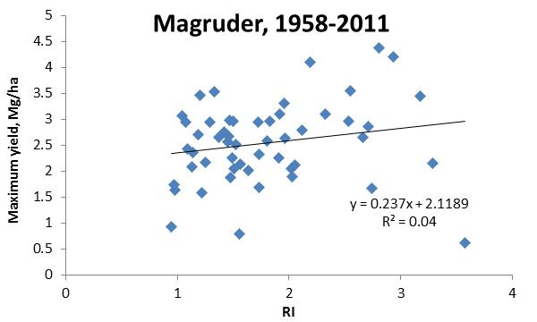

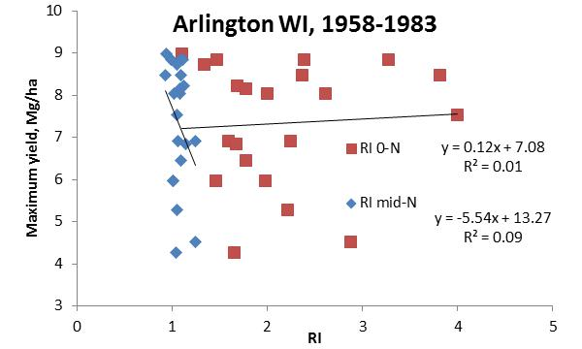

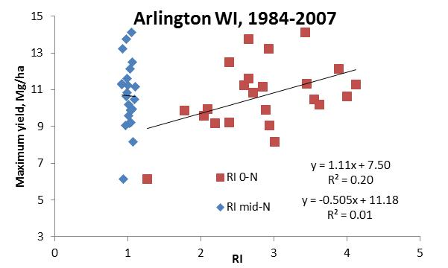
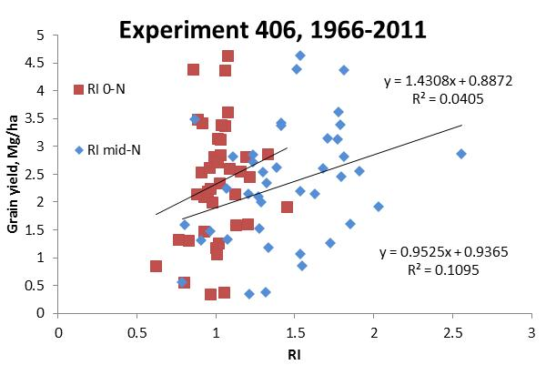

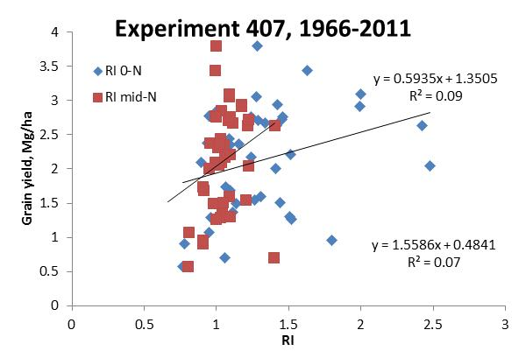

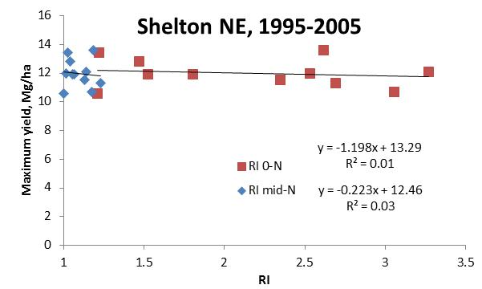

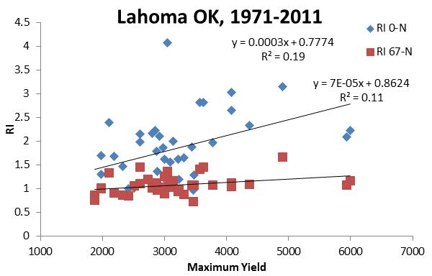

APPENDIX
Accepted Theory
The following quote from Liebig (1859) illustrates the importance of shifting our views and revisiting our current understanding of principles and theories. But, it also implies holding fast to current art and understanding of our trade.
“The progress of every trade by mere empirical experience, and also that of agriculture, has a limit. Every experimental method comes to an end when the senses are no longer sufficient for the perception of facts; when no new circumstance is presented to the senses for perception; when, in short, everything has been tried, and the facts resulting from such trials have been adopted into the particular art of trade. Further progress can then only be looked for, if hidden facts are sought out, the senses are sharpened for their perception, and the means of investigation are improved. But such a course is not possible without reflection, without the mind also taking its share in the operation.”

