Hand Planter for Maize (Zea mays L.) in the Developing World
Peter Omara, Rajen Bajgain, Randy Taylor, Adrian Koller, Eric Lam, Joshua Ringer, Jeremiah Mullock, Sulochana Dhital, Natasha Macnack, and Bill Raun

Abstract
Third world maize (Zea mays L.) production is characterized by having extremely low yields, attributed in part to the poor planting methods employed. Maize planting in most third world countries involves placing two to three seeds per hill, with hills being roughly 30 cm apart. The variability in seeds per hill and distance between hills results in heterogeneous plant stands that are directly responsible for lower yields. Oklahoma State University (OSU) has developed a durable hand planter with a reciprocating internal drum that delivers single maize seeds per strike and that can also be used for mid-season application of urea fertilizer. The hand planter is 1.4 m in length, 5.8 cm in diameter and weighs 1.9 kg when empty. The seed hopper has the capacity to hold 1 kg of seed and the tip has a sharp pointed shovel which can deliver seed to a planting depth of 5cm in no-till and tilled soils. The current prototype has been comprehensively tested and evaluated to deliver at least 80% single seeds (singulation), 0% misses, work well across varying seed sizes (2652 to 4344 seeds/kg), and different operators. Using the OSU hand planter, third world maize producers with average yields of 2.0 Mg ha⁻¹, could increase yields by 20%.

Keywords: Hand planter, Maize, Plant population

Introduction
Maize is one of the most important cereal crops in the world and serves as a source of food and income for many communities around the globe. In the developing world, maize is a staple caloric source accounting for as much as 50% of that consumed in some African countries (FAO, 2011). Current annual global maize production is estimated to be about 883 million MT of which roughly 180 million MT (20 % of world production) is produced in Latin America and Africa (FAO, 2011). Ray et al. (2013) argued that the production level in third world countries where maize is so important, needs to be doubled in order to meet the rising population demand by 2050. However, the development of soil fertility and improved production techniques have fallen behind in many of these countries, resulting in average yields as low as 1.8 Mg ha⁻¹ (FAO, 2011). Adoption of more efficient production practices are needed to overcome the low productivity commonplace in the third world (Du Plessis, 2003). Intervention by government, non-governmental organizations, and other development partners has focused on developing higher yielding varieties. However, Bekele et al. (2011) noted that using high yielding varieties will not necessarily increase maize yields, unless complemented with improved agronomic practices. In addition, Heisey and Mwangi (1996) noted that yield increases rather than area expansion will become progressively more important for increasing crop production as agricultural land is becoming scarce in Sub-Saharan Africa.
In developed countries, maize is planted using mechanized planters that deliver single seeds at equal depths and spacing resulting in homogenous plant stands and increased yields. Production practices currently used for maize planting in developing countries are labor intensive and inefficient (Pradhan et al., 2011). The poor socio-economic conditions of farmers in most developing countries, has limited maize planting mechanization; in many of these countries maize planting is associated with the use of a heavy stick planter and hand hoes (Adjei et al., 2003). The planting stick consists of a wooden shaft with a pointed metal tip to penetrate the soil thus making a hole/depression for seed placement (FAO, 2010). Traditional planting techniques consist of placing two to three seeds within the hole (shaft/tip depression created when striking the ground, commonly referred to as ‘hill’) and then seeds are covered by the surrounding soil. The process is labor intensive, results in multiple seeds emerging per hill, and non-uniform plant stands (Aitkins et al., 2010).
Non-uniform plant stands can increase inter-plant competition and decrease yields (Nafziger et al., 1991). Doerge et al. (2002) reported that for each inch improvement in the standard deviation of equidistant plant spacing, yields can be increased up to 0.25 Mg ha⁻¹. The authors also found that when plants were within a 0.05 to 0.07 meter of perfect equidistant spacing maximum by-plant yields were achieved. Boomsma et al. (2011) noted that high plant densities result in reduced per-plant resource availability, increased plant competition, decreased productivity, developmental variability, and ultimately lower yields. In addition to potential yield and economic losses, seeds are often pre-treated with fungicides, introducing a health risk to the farmer when seeds are handled by hand. These factors and the high price that producers pay for acceptable maize seed, make the improved use of this resource necessary. Chim et al. (2013) showed that 1 seed per hill at 0.16 m spacing, increased yields by 0.2-0.9 Mg ha⁻¹ compared to planting 2-3 seeds at 0.32 and 0.48 m plant spacing.
The development of a planter with the ability to make a hole and release a single seed upon penetration of the soil would improve homogeneity of the plant population, decrease intra specific competition and improve yield potential. The objective of this work was to design and test a hand operated, light-weight planter that could reliably deliver one seed per strike in various soil textures and tillage systems, regardless of seed size and operator.

Materials and Methods
Prototype Description and Operation
Oklahoma State University has developed a hand planter that weighs 1.9 kg, with the capacity to contain up to 1 kg of seed of various sizes. The seed hopper/handle is made of a polyvinyl chloride (PVC) round pipe with a diameter of 5.8 cm (Figure 1). Attached to the hopper is a seed metering delivery system which consists of a short tube containing a reciprocating drum, spring, and brush (Figure 2). The drum cavity depth and angle are crucial for determining the number of seeds that are released with each strike. The drum cavity is overladen with seed that feeds from the hopper, and via a reciprocating drum motion receives one seed at a time using a brush that passes over the cavity, thus removing excess seeds. Brushes of differing tensile strength can be used as necessary for differing seed sizes and shapes. The movement of the drum is facilitated by the force applied on the spring when the planter is pressed downward. A sharp pointed tip/shovel is attached to the metering device and that can plant seed to a depth of 5 cm in no-till and tilled soils when the planter tip penetrates the soil.
The planter is designed for “up-stroke” seed release, where the operator creates a hole in the soil by pushing the tip into the ground. This movement compresses a spring and rotates the drum to capture each seed in the drum cavity. When the spring is released on the “up-stroke”, the drum rotates back to release the seed within the soil depression created by the tip. A down-stroke release is also possible by rotating the lever attached to the drum (requires altered design not shown in Figures 1 or 2). Representative rotating drums that were tested are shown that accommodate differing seed sizes (Figure 3).

Variability in Maize Seeds
The inherent differences in maize seed size, weight, and shape can significantly affect the performance of the planter. Initially, the weight of seeds per kg was used as the only criterion for determining performance of the drum. Tests were conducted on seeds ranging from 2652 to 4344 seeds/kg. For a fixed cavity size, smaller seeds (>4000 seeds/kg) had more multiples with fewer misses compared to larger seeds (<3000 seeds/kg). With cavity size, depth, and angle design improvements, the number of singles was significantly improved, and the number of multiples and misses were reduced with repeated modification of the seed metering unit. Some seeds have the same density (seeds/kg) but have different shapes (medium flats, small round, large round, etc.). However, seed density (seeds/kg) and volume (seeds/L), determined via water displacement were found to have a 1:1 relationship (Figure 4). Thus either method can be used to determine drum size for differing seed sizes.
Prototype Development and Progress
Hand planter development and evaluation has required testing of various designs. Initially a square housing with an external spring was used to rotate a reciprocating drum with a prefabricated cavity capable of holding 1 to 2 maize seeds (Figure 5). The current design employs a round housing with an internal spring (Figure 2). The primary focus was to develop a hand planter that delivers at least 80 percent single seeds, and no more than 5 percent misses (no seed delivered). Seed metering of the planter depends on the drum and brush specifications. Many drums with varying cavity depth (mm) and angle (degrees) have been tested, together with brushes of varying stiffness. The results presented here for the drum, however, combined two cavity angles (20 & 25 degrees) for each cavity depth (Table 1). With constant modification and development, the number of misses has been reduced and the singulation percentage has increased. Figure 6 shows the performance of the drum and brush combinations. Drums with larger cavity depth and angle had more strikes with multiple seeds delivered and fewer misses while drums with a smaller cavity had a higher percentage of misses. In the process of drum modification, more multiple seeds per strike have been allowed in order to obtain fewer strikes with no seeds delivered. This should also assist in decreasing variability in percent emergence.
An added benefit of the hand planter that has been developed is sidedress application of granular fertilizer. For the application of 50 kg N/ha as urea (by plant basis, 70,000 plants per hectare) an internal drum was easily modified to deliver 1.6 g per plant per strike. Furthermore, the present drum planting system could easily be altered to accommodate seeds from a range of crops and/or alternative products where singulation was desired.

Field Performance Testing
Field performance testing was conducted at the OSU Agronomy Research Station in Stillwater, OK to evaluate emergence of maize seeds. A randomized complete block design was used with 3 replications and 13 treatments; consisting of 2 housings (H1st and H1so), 2 drum sizes (450s and 450b), and 3 seed sizes (3572, 3263 and 2652). All treatments were planted with Pioneer hybrid maize seed on tilled ground, 0.76m apart. Emergence counts, including single and multiple seeds, were taken and percent emergence (%) for each treatment was averaged from the three replications. Results for the emergence counts for different treatments are summarized in a bar chart presented in Figure 7.

Conclusions and Recommendations
The inherent differences in maize seed make it hard to have a universal drum that works for the array of seed sizes found around the world. Future users of the hand planter are encouraged to first evaluate the drum cavity using seed within their region. Drum cavity size and depth can then be altered to accommodate the seed used within each production region so as to optimize seed singulation. Furthermore, field observations have shown ergonomic differences among operators. This has impacted planting depth and the precision with which seeds are planted in the soil. Simple training is required for third world users allowing for more precise delivery of maize seed into the soil.
Significant progress has been made in planter design and singulation results. Current OSU hand planter models have surpassed the initial target goal of 80 percent singulation. The number of multiples and misses using the ‘up-stroke’ release design have also been reduced through continuous evaluation and modification. However, the up-stroke design is more cumbersome as it involves the back and forward motion of the planter to create an adequate hole for the single seed planting. Observations from field testing indicate that the ‘down-stroke’ releasing drum design has more promise. Although this design still has lower singulation, it is easier to use, does not involve a back and forward motion and has less soil clogging in the planter tip. Current work is focused on improving singulation and reducing misses in the ‘down-stroke’ design. Once this design is fully vetted, it will be evaluated under various field conditions, modifying the planter tip to allow for the best soil-seed contact.

References
Adjei E.O., S.H.M. Atkins, P. Boahen, K. Chand, I. Dev, M. Lu, V. Mkrtumyan, S.D. Samarweera and A. Teklu. 2003. Combining mechanization and conservation agriculture in the transitional zone of Brong Ahafo Region, Ghana. ICRA Working Documents Series 108, International Centre for Development Oriented Research in Agriculture, Wageningen
Aikins, S. H. M., A. Bart-Plange and S. Opoku-Baffour. 2010. Performance evaluation of jab planters for maize planting and inorganic fertilizer application. J. Agr. and Bio. Sci. 5(1): 29-33.
Bekele, S., B. M. Prasanna, J. Hellin, and M. Banziger. 2011. Crops that feed the world 6. Past successes and future challenges to the role played by maize in global food security. Food Security 3(3): 307-327.
Boomsma, C.R, J.P. Lynch and T.J. Vyn. 2011. Resource Availability and Plant-to-Plant Competition in Maize: Implications for 21st Century Maize Genetic and Agronomic Improvement. Proceedings of the 47th Illinois Corn Breeders School. University of Illinois Urbana, IL.
Doerge, T., T. Hall, and D. Gardner. 2002. New research confirms benefits of improved plant spacing in corn. Crop Insights. 12(2): 4. Pioneer Hi-Bred Int., Johnston, IA.
Du Plessis, J. 2003. Maize Production. Department of Agriculture, Directorate Agricultural Information Services, Pretoria, South Africa. p. 1

FAO. 2010. Conservation Agriculture of Natural Resources for Sustainable Agriculture. http://www.fao.org/ag/ca/Training_Materials/guide_tools_equipment_animal.pdf. (accessed 16 Jul. 2013). FAO, Rome.
FAO. 2011. Subset production crops database. http://faostat3.fao.org/home/index.html (accessed 18 Feb. 2013). FAO, Rome
Heisey, P.W. and W. Mwangi, 1996. Fertilizer Use and Maize Production in Sub-Saharan
Africa. CIMMYT Economics Program Working Paper 96-01. Mexico, D.F.: CIMMYT.
Chim, Bee Khim, Natasha Macnack, Peter Omara, and William Raun. 2013. Effect of seed distribution and population on maize (Zea mays L.) grain yield.
Nafziger, E.D., P.R. Carter and E.E. Graham. 1991. Response of corn to uneven emergence. Crop Sci. 31:811-815.
Pradhan, P.L., J.N. Mishra, and S.K. Nanda. 2011. Development and evaluation of a power tiller operated planter for maize. J. Agr. Mech. in Asia, Africa and Latin America. 42 (4): 67-71.

Ray, D.K., N.D. Mueller, P.C. West and J.A. Foley. 2013. Yield Trends Are Insufficient to Double Global Crop Production by 2050. PLoS ONE 8(6): e66428. doi:10.1371/journal.pone.0066428

Table 1: Treatment means for brush (T4-T8) and drum combinations (235, 260) including misses, singles, and multiple seeds.
Brush | Drum (mm) | Misses | Singles | Multiples
 |  |  | Means (%)
T4 | 235 | 6.5 | 90 | 3.5
T4 | 260 | 3 | 85 | 12
T5 | 235 | 6 | 64 | 30
T5 | 260 | 5 | 65 | 30
T6 | 235 | 4 | 76 | 20
T6 | 260 | 2 | 64 | 34
T7 | 235 | 5.5 | 89 | 5.5
T7 | 260 | 4 | 78 | 18
T8 | 235 | 14 | 84 | 2
T8 | 260 | 8.5 | 85 | 5.5
235 and 260 are drum cavity depth (mm), T4 to T8 are test brushes

Table 2: Maize hybrids, density (seeds kg⁻¹) and volume (ml kg⁻¹) of maize seed used in this study
Hybrid | Density (seeds kg⁻¹) | Volume (ml kg⁻¹)
DKC 62-09 | 4210 | 5263
DKC 62-26 | 4344 | 5556
DKC 63-55 | 3263 | 4255
PO876HR | 4050 | 5263
P1395XR | 3846 | 4444
P1395YHR | 2652 | 3448
P1395AM1 | 3577 | 4545
P1498HR | 3017 | 3846

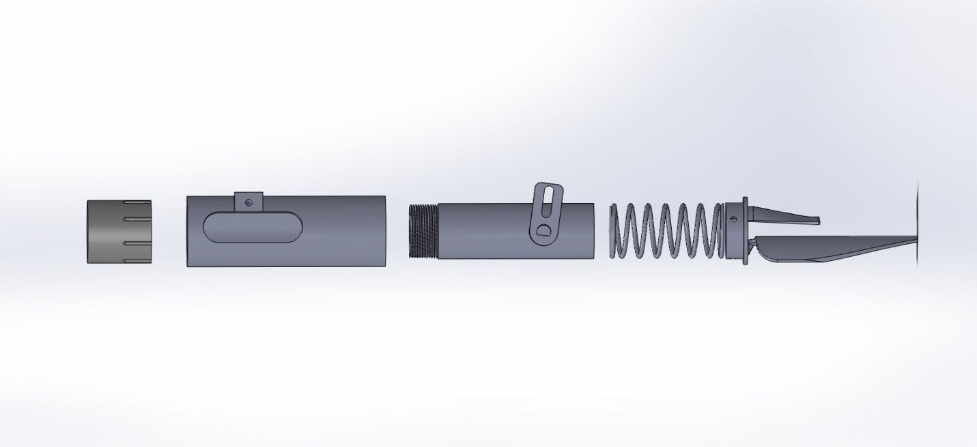
Figure 1: Side view of the maize hand planter showing (left to right, coupler, external housing, internal housing with rotating arm, spring and planter tip, developed at Oklahoma State University.

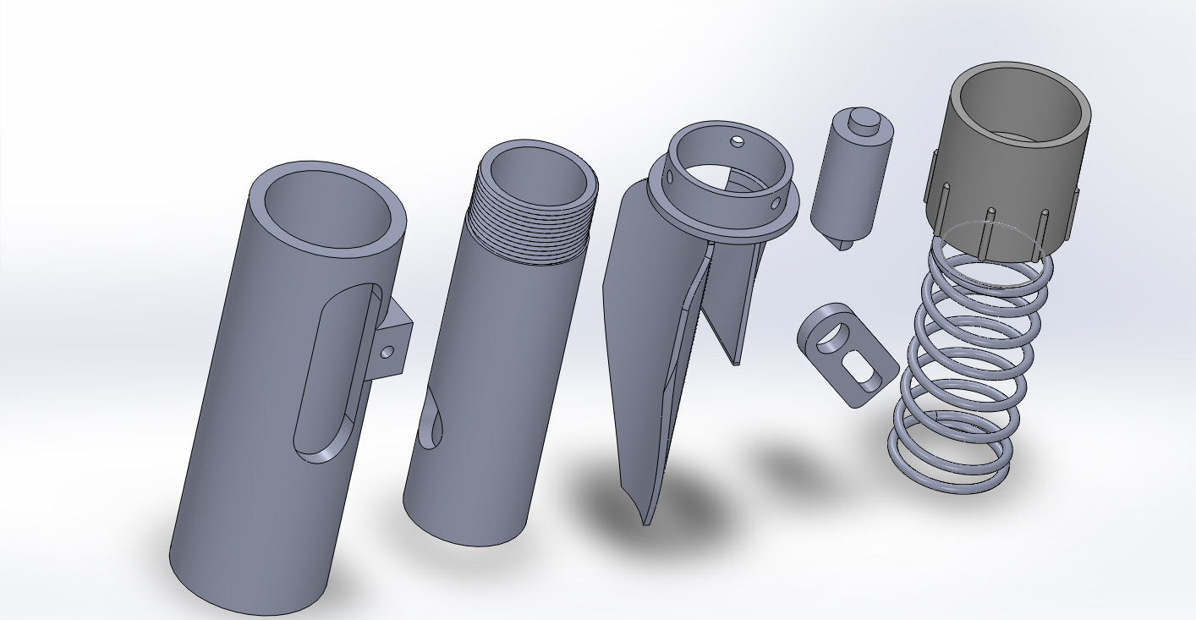
Figure 2: Components of seed metering unit (left to right), including external housing, internal housing planter trip, rotating drum, rotating arm, connecting coupler, and internal spring, Oklahoma State University.

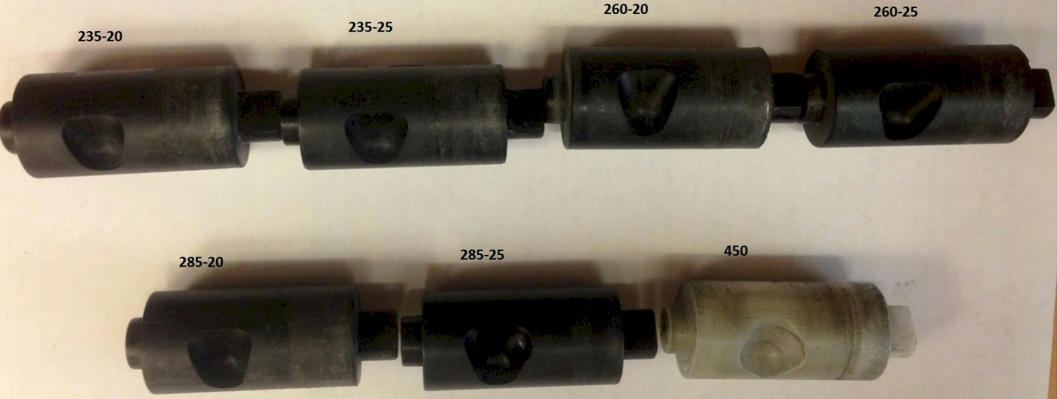

Figure 3: Internal rotating drums with different cavity depths, size, and angle.

Figure 4: Regression analysis showing the relationship between volume, seeds L ⁻¹ and density, seeds kg ⁻¹.

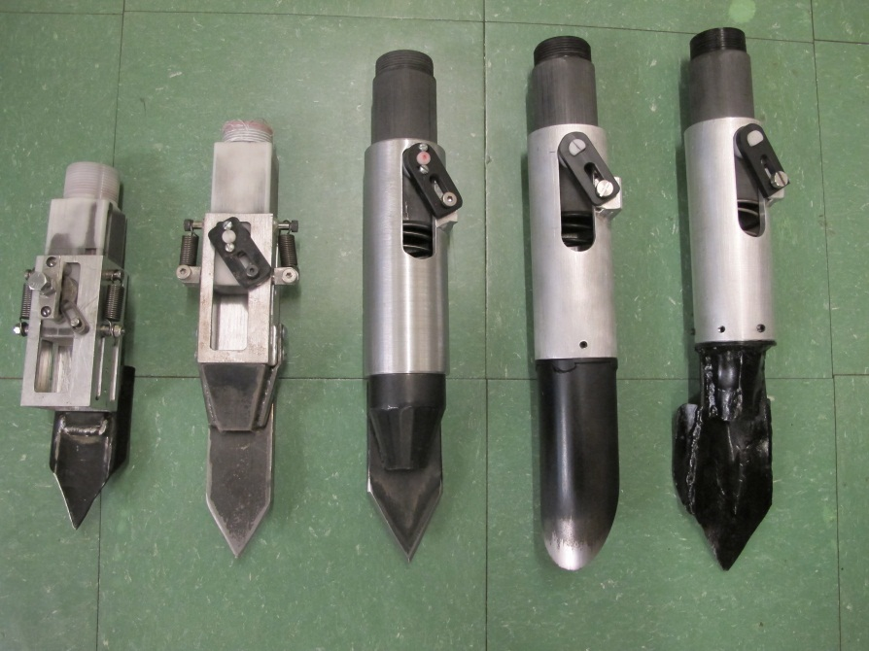
Figure 5: Sequential development (left to right) of the hand planter showing design progress and tip modification 2011 through 2013.

Figure 6: Distribution of maize singles and misses for brush and drum combinations averaged over 10 planter strikes (T-values represent different brush sizes and stiffness, 235 and 260 represent drum cavity depth in mm), September 2013.

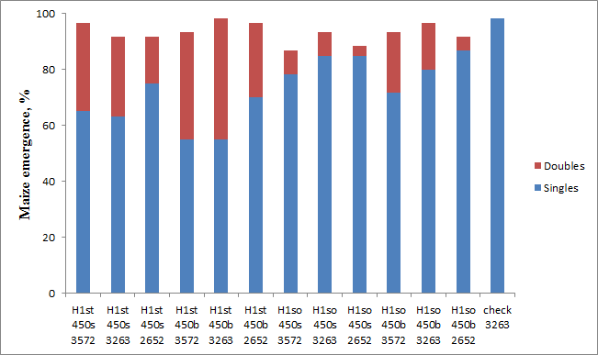
Figure 7: Field performance and emergence tests on seed-drum combinations.

